**Q: Describe using ER : The elements writer, novel, and consumer**

**Soln:**

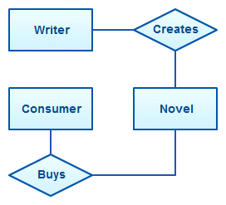

**Q: An inventory software used in a retail shop will have a database that monitors elements such as purchases, item, item type, item source and item price.**

**Soln:**

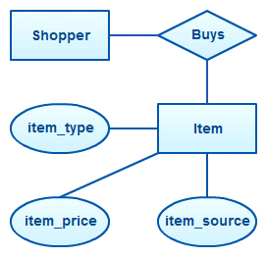

**Q: An attribute “customer address” can have the attributes number, street, city.**

**Soln:**

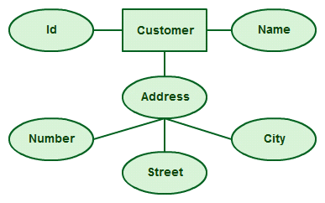

**Q: A** **teacher entity can have multiple subject values.**

**Soln:**



**Q: The order item will be meaningless without an order so it depends on the existence of order.**

**Soln:**



**Q: a circle the area can be derived from the radius**.

**Soln:**

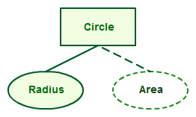

**Q: The entity “carpenter” may be related to the entity “table” by the relationship “builds” or “makes”.**

**Soln:**

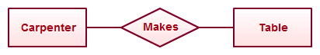

**Q: An employee can be a supervisor and be supervised.**

**Soln:**

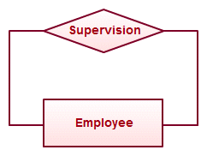

**Q: In an email system, one account can have multiple contacts.**

**Soln:**

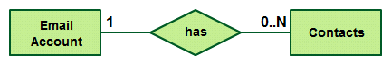

**Q: A simple Exam database:**

* **Students take up exams in such a way that 1 student can take one exam only**
* **The student ‘s name and contact details like email and phone is to be taken from the Student. Student also has a Student number which is unique.**
* **All the exams has exam number unique to exams and the subject related.**
* **The resulting scores of the exams are recorded in report card which contains the record number, name, subject and score.**

**Soln:**

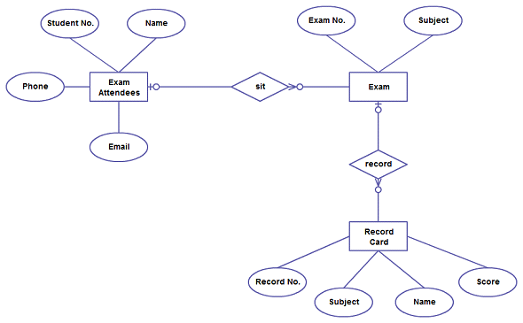

**Question:**

**The Prescriptions-R-X chain of pharmacies has o_ered to give you a**

**free lifetime supply of medicines if you design its database. Given the rising cost of**

**health care, you agree. Here's the information that you gather:**

**Patients are identi_ed by an SSN, and their names, addresses, and ages must be**

**recorded.**

**Doctors are identi_ed by an SSN. For each doctor, the name, specialty, and years**

**of experience must be recorded.**

**Each pharmaceutical company is identi_ed by name and has a phone number.**

**For each drug, the trade name and formula must be recorded. Each drug is**

**sold by a given pharmaceutical company, and the trade name identi_es a drug**

**uniquely from among the products of that company. If a pharmaceutical company**

**is deleted, you need not keep track of its products any longer.**

**Each pharmacy has a name, address, and phone number.**

**Every patient has a primary physician. Every doctor has at least one patient.**

**Each pharmacy sells several drugs and has a price for each. A drug could be sold**

**at several pharmacies, and the price could vary from one pharmacy to another.**

**Doctors prescribe drugs for patients. A doctor could prescribe one or more drugs**

**for several patients, and a patient could obtain prescriptions from several doctors.**

**Each prescription has a date and a quantity associated with it. You can assume**

**that if a doctor prescribes the same drug for the same patient more than once,**

**only the last such prescription needs to be stored.**

**Pharmaceutical companies have long-term contracts with pharmacies. A phar-**

**maceutical company can contract with several pharmacies, and a pharmacy can**

**contract with several pharmaceutical companies. For each contract, you have to**

**store a start date, an end date, and the text of the contract.**

**Pharmacies appoint a supervisor for each contract. There must always be a super-**

**visor for each contract, but the contract supervisor can change over the lifetime**

**of the contract.**

**1. Draw an ER diagram that captures the above information. Identify any con-**

**straints that are not captured by the ER diagram.**

**2. How would your design change if each drug must be sold at a _xed price by all**

**pharmacies?**

**3. How would your design change if the design requirements change as follows: If a**

**doctor prescribes the same drug for the same patient more than once, several such**

**prescriptions may have to be stored.**

**Soln:**

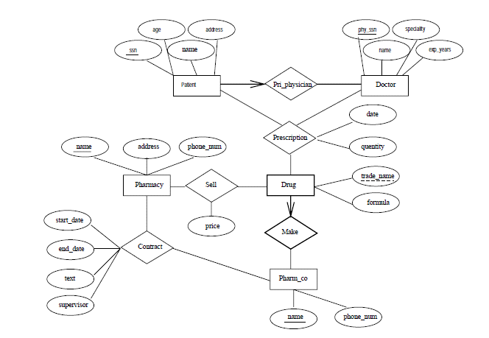

**Q:** Suppose you are given the following requirements for a simple database for the National Hockey League (NHL):

* the NHL has many teams,
* each team has a name, a city, a coach, a captain, and a set of players,
* each player belongs to only one team,
* each player has a name, a position (such as left wing or goalie), a skill level, and a set of injury records,
* a team captain is also a player,
* a game is played between two teams (referred to as host_team and guest_team) and has a date (such as May 11th, 1999) and a score (such as 4 to 2).

Construct a clean and concise ER diagram for the NHL database.

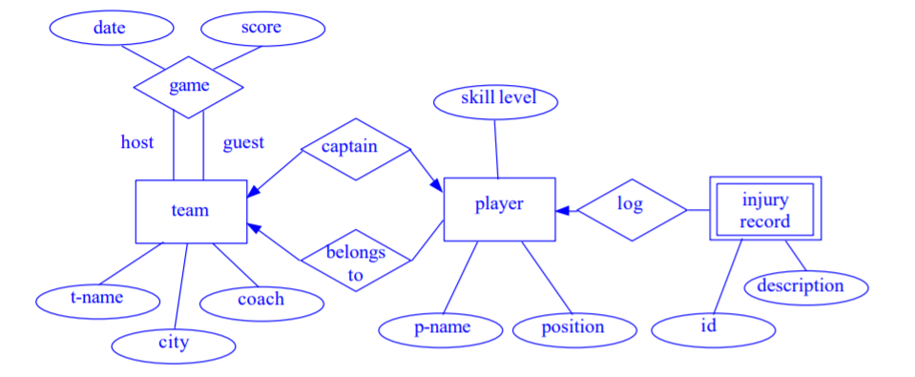

**Q:** A university registrars office maintains data about the following entities:

1. courses, including number, title, credits, syllabus, and prerequisites;
2. course offerings, including course number, year, semester, section number, instructor(s), timings, and classroom;
3. students, including student-id, name, and program;
4. instructors, including identi‑cation number, name, department, and title.

Further, the enrollment of students in courses and grades awarded to students in each course they are enrolled for must be appropriately modeled. Construct an E-R diagram for the registrar office. Document all assumptions that you make about the mapping constraints.

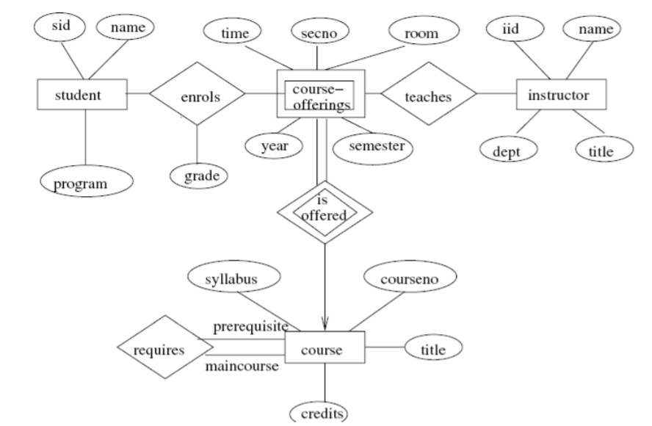

**EER:**

Q: Consider a bank, and model the following two aspects:

• There are three different kinds of ACCOUNTs, namely SAVINGS_ACCTs,

CHECKING_ACCTs and TRUSts. For each ACCOUNT we have to take care of

its TRANSACTIONs. Each TRANSACTION has a *type* such as “deposit”,

“withdrawal” or “check”. Furthermore, each transaction has a *date/time*

(consisting of a *date* and a *time*) and an *amount*.

• There are different kinds of LOANS, namely CAR_LOANS, HOME_LOANS,

CREDIT_LINE and PERSONAL ones. For each LOAN we have to take care of

its PAYMENTs. Each PAYMENT has a *type*, *date* and *amount*



**Q:**

Consider the following information about a university database:

Professors have an SSN, a name, an age, a rank, and a research specialty.

Projects have a project number, a sponsor name (e.g., NSF), a starting date, an

ending date, and a budget.

Graduate students have an SSN, a name, an age, and a degree program (e.g., M.S. or Ph.D.).

Each project is managed by one professor (known as the project's principal investigator).

Each project is worked on by one or more professors (known as the project's co-investigators).

Professors can manage and/or work on multiple projects.

Each project is worked on by one or more graduate students (known as the project's research assistants).

When graduate students work on a project, a professor must supervise their work on the project. Graduate students can work on multiple projects, in which case they will have a (potentially different) supervisor for each one.

Departments have a department number, a department name, and a main office.

Departments have a professor (known as the chairman) who runs the department.

Professors work in one or more departments, and for each department that they work in, a time percentage is associated with their job.

Graduate students have one major department in which they are working on their degree.

Each graduate student has another, more senior graduate student (known as a student advisor) who advises him or her on what courses to take.

Design and draw an ER diagram that captures the information about the university.

Use only the basic ER model here, that is, entities, relationships, and attributes. Be sure to indicate any key and participation constraints.

**Solution:**

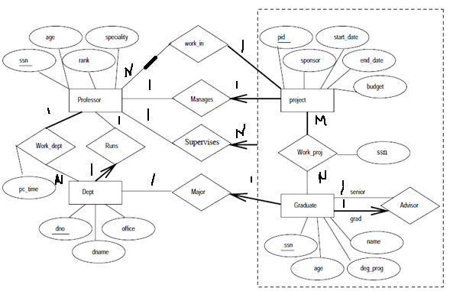

**Q:**

Notown Records has decided to store information about musicians who perform on its albums (as well as other company data) in a database. The company has wisely chosen to hire you as a database designer (at your usual consulting fee of $2,500/day).

Each musician that records at Notown has an SSN, a name, an address, and a phone number. Poorly paid musicians often share the same address, and no address has more than one phone.

Each instrument that is used in songs recorded at Notown has a name (e.g., guitar, synthesizer, flute) and a musical key (e.g., C, B-flat, E-flat).

Each album that is recorded on the Notown label has a title, a copyright date, a format (e.g., CD or MC), and an album identifier.

Each song recorded at Notown has a title and an author.

Each musician may play several instruments, and a given instrument may be played by several musicians.

Each album has a number of songs on it, but no song may appear on more than one album.

Each song is performed by one or more musicians, and a musician may perform a number of songs.

Each album has exactly one musician who acts as its producer. A musician may produce several albums, of course.

Design a conceptual schema for Notown and draw an ER diagram for your schema. The following information describes the situation that the Notown database must model.

Be sure to indicate all key and cardinality constraints and any assumptions that you make. Identify any constraints that you are unable to capture in the ER diagram and briefly explain why you could not express them.

**Solution:**

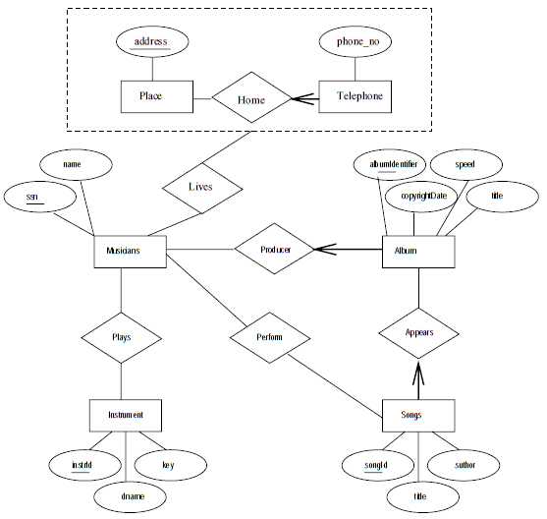

**Q:**

The Prescriptions-R-X chain of pharmacies has o_ered to give you a free lifetime supply of medicines if you design its database. Given the rising cost of health care, you agree. Here's the information that you gather:

Patients are identified by an SSN, and their names, addresses, and ages must be recorded.

Doctors are identified by an SSN. For each doctor, the name, specialty, and years of experience must be recorded.

Each pharmaceutical company is identified by name and has a phone number.

For each drug, the trade name and formula must be recorded. Each drug is sold by a given pharmaceutical company, and the trade name identifies a drug uniquely from among the products of that company. If a pharmaceutical company is deleted, you need not keep track of its products any longer.

Each pharmacy has a name, address, and phone number.

Every patient has a primary physician. Every doctor has at least one patient.

Each pharmacy sells several drugs and has a price for each. A drug could be sold at several pharmacies, and the price could vary from one pharmacy to another.

Doctors prescribe drugs for patients. A doctor could prescribe one or more drugs for several patients, and a patient could obtain prescriptions from several doctors.

Each prescription has a date and a quantity associated with it. You can assume that if a doctor prescribes the same drug for the same patient more than once, only the last such prescription needs to be stored.

Pharmaceutical companies have long-term contracts with pharmacies. A pharmaceutical company can contract with several pharmacies, and a pharmacy can contract with several pharmaceutical companies. For each contract, you have to store a start date, an end date, and the text of the contract.

Pharmacies appoint a supervisor for each contract. There must always be a supervisor for each contract, but the contract supervisor can change over the lifetime of the contract.

1. Draw an ER diagram that captures the above information. Identify any constraints that are not captured by the ER diagram.

2. How would your design change if each drug must be sold at a fixed price by all pharmacies?

3. How would your design change if the design requirements change as follows: If a doctor prescribes the same drug for the same patient more than once, several such prescriptions may have to be stored.

**Solution:**



